EENG 284 – Digital Design

Lab 09 – Stop Watch Datapath

# Objective

The objective of this lab is to design a datapath to store and manipulate the information need to run a stopwatch.

**1 Discussion**

A stopwatch is a device that is used to measure time intervals, usually in competitive events. The stopwatch that you will be designing gets its input from two buttons. The stopwatch will measure down to a 1/10th of a second. The time will be displayed using 3 digits which will represent tenths of a second, unit second and tens of seconds. As a result, the stopwatch is limited to measuring intervals of time from 0.1 second to 99.9 seconds.

The stopwatch’s behavior is dictated by its 2 buttons called S1 and S2 according to the finite state machine shown in Figure 1.

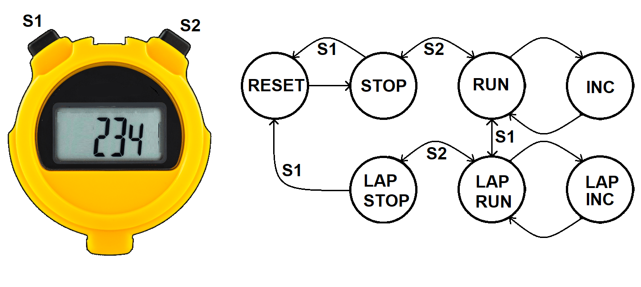

Figure 1: A digital stopwatch gets its input from 2 buttons and displays its output on a 7-segment display. The behavior of the stopwatch can be described by this finite state machine (FSM).

To make sense out of the FSM shown in Figure 1, its helpful to imagine timing a 4-person relay race. In this race, each athlete runs one lap and then pass a baton to the next runner. The time required for a runner to complete one lap is called their split time. In order to measure each runner’s split time, you need to be able to stop the displayed time while allowing the stopwatch to continue to run its internal timer. This is called a lap feature. Let’s explore how the lap feature works by timing the mile relay at a Mines track meet. As we go through this scenario, reference the finite state machine in Figure 1.

Prior to the start of the race, you push button S1 putting the stopwatch into the RESET state. This clears the internal timer and the displayed time. The stopwatch automatically goes back to the STOP state. You are ready for the start of the race. You are ready when the gun goes off and immediately press button S2 putting the stopwatch into the RUN state. The internal timer is keeping track of the elapsed time and you this the displayed time changing to reflect the internal timer. As soon as the first runner who is finishing their lap hands the baton to the second runner, you press button S1 putting the stopwatch into the LAP RUN state. This causes the displayed time to stop, showing the time at the instant you pressed button S1, while simultaneously allowing the internal timer to keep running. The internal timer is now keeping track of the elapsed time since the start of the race. You calmy write down the displayed time on your clip board (made easier because it is not changing) and then press button S1 putting the stopwatch back into the RUN state. You repeat this process until the last runner comes in. As soon as they do, you press button S2 stopping the internal timer and showing the time the last runner crossed the finish line.

In this scenario we did not put the stopwatch into the LAP STOP state – this state would stop the internal timer and keep the displayed time the moment the S1 button was pressed when the stopwatch was in the RUN state. You should also note, we did not talk about the INC and LAP INC states. Let’s explore them now.

Clearly, the stopwatch does not increment the stored and displayed time at 50Mhz. The stored and displayed time count up every 10th of a second. This is managed by the counter/comparator at the top of Figure 2 which asserts the **tenth** signal every 10th of a second. This signal tells the FSM in Figure 1 to transition from the RUN state to the INC state. In the INC state the stored time is incremented and the counter at the top of Figure 2 is reset back to 0. The LAP INC state performs a similar function for the LAP state.

To summarize:

* RESET – Reset the internal and displayed time values.
* STOP – Stop the 10th second timer and hold the displayed time.
* RUN – Run the 10th second timer and display the stored time.
* INC – Increment the stored time
* LAP RUN – Run the 10th second timer and hold the displayed time.
* LAP INC - Increment the stored time.
* LAP STOP – Stop the 10th second timer and hold the displayed time.

**2 Datapath Architecture**

The datapath for the stopwatch is shown in Figure 2. The behavior of the datapath to perform the functions of a stopwatch follows.

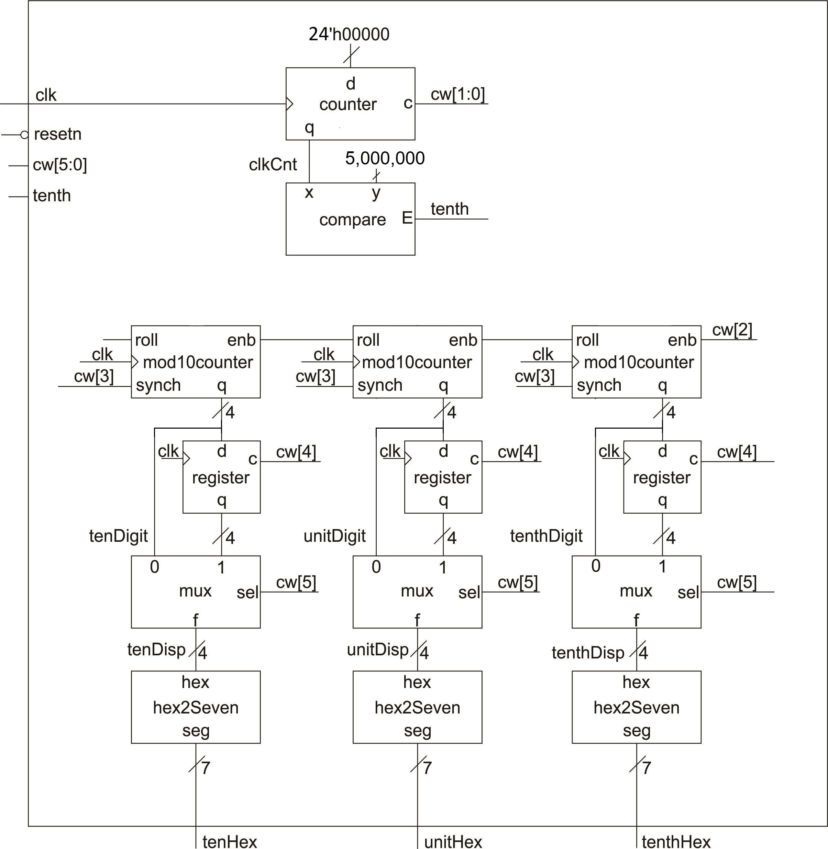

Figure 2: The datapath for the stopwatch has a 6-bit control word and displays the time on three 7-segment displays.

The internal time is formed by the counter/comparator combination at the top of Figure 2. The **clk** input from the Development Board runs at 50MHz. This will be the rate at which the **clkCnt** output from counter counts up. When **clkCnt** counts from 0 to 5,000,000 then 1/10th of a second has gone by. The **roll** signal indicates when 1/10th of a second has gone by. The control unit you build will build in the next lab, will use this signal to coordinate incrementing the bank of mod 10 counters in the datapath. Note that the bank of mod 10 counters are incremented in a state called INC, that is not shown in Figure 1. The output of the mod10 counters, **tenDigit**, **unitDigit** and **tenthDigit** can be latched-up in the register bank so that the datapath can hold the displayed time while still allowing the bank of mod 10 counters to keep track of the elapsed time. The multiplexer controls what is displayed. The 4-bit digit representing a time digit, **tenDisp**, **unitDisp** and **tenthDisp** are converted into a 7-segment pattern before leaving the datapath.

To better understand the datapath, construct the control word for each state. In order to help you, the actions associated with each state are outlined below. In some cases, you will need to make decisions about the control bits. Use your understanding of the datapath’s operation and your intuition of how you would want to the datapath to work. If this is uncomfortable, please understand that it’s important for you to learn how to make design decisions on your own so that you can reach your full potential as an engineer.

* RESET – clear the values in the registers and counters
* STOP – hold the timer counter and display the mod 10 counters
* RUN – allow the timer counter to count up and display the mod 10 counters
* INC – clear the timer counter and increment the mod 10 counters
* RUN2LAP – Latch up the mod 10 counters in the lap register
* LAP RUN – allow the timer counter to count up, display the latched time
* LAP INC – clear the timer counter and increment the mod 10 counters
* LAP STOP – stop the timer counter and display the latched time

Table 1: Control word table for the datapath shown in Figure 2.

|  |  |  |  |  |  |
| --- | --- | --- | --- | --- | --- |
|  | **cw[5]**  **2x1 mux** | **cw[4]**  **lap register** | **cw[3]**  **mod10 reset** | **cw[2]**  **mod10 count** | **cw[1:0]**  **timer counter** |
|  | 0 = mod10 | 1 = load | 1 = reset | 1 = count up | 11 = load |
|  | 1 = register | 0 = hold | 0 = hold | 0 = hold | 10 = count up |
|  |  |  |  |  | 01 = not used |
|  |  |  |  |  | 00 = hold |
| **RESET** |  |  | 1 |  |  |
| **STOP** |  |  |  |  |  |
| **RUN** |  |  |  |  |  |
| **INC** |  |  |  |  |  |
| **RUN2LAP** |  |  |  | 0 |  |
| **LAP RUN** |  |  |  |  | 10 |
| **LAP INC** |  | 0 |  |  |  |
| **LAP STOP** | 1 |  |  |  |  |

Now that you have the control word figured out, you need to write the Verilog code for the datapath. For the datapath module, I want you to:

* Use the datapath.v file provided in the Canvas folder as the starting point.
  + Use the module definitions from previous land and the Canvas lab folder for this lab.
* Provide meaningful names to the wires in the module.
* Properly tab-indent your code
  + Single level for wire declarations
  + Single level for component instantiations
  + Two levels for case statement
  + Three levels for case values

**3 Datapath Simulation**

Before you download your completed datapath to the Development Board, you are going to perform extensive simulations to uncover as many bugs as possible. Trust me, errors are much, much easier to find in a simulation.

There is a practical consideration that will make the simulation more manageable. The counter-comparator combination in Figure 2 acts as a clock divider circuit. The counter counts up at 50MHz (the main oscillator frequency). The comparator checks when the count reaches 5,000,000 = 0x4C4B40, meaning that a 1/10th of a second has gone by. You do not want to have to run the counter to 5,000,000 in your simulation, it would just take too long. To replace the 5,000,000 constant you need to go into the datapath.v module and modify the following:

* localparam **tenthSecondConstant** to 4'h000002 (an arbitrary small constant)
* parameter **N** to 4, this sets the word size of the counter/comparator hardware.

You can use the parameter **N** as the generic parameter in component instantiation for generic components. For example, in my datapath, I have the following genericCounter instantiation - the use of the parameter value #(N) as the width of the counter is legal syntax in Verilog.

genericCounter #(N) tenthSecondCounter(clk, resetn, zero24, cw[1:0], clkCount);

Make a note to yourself to modify **N** and **tenthSecondConstant** values before synthesis. This is also mentioned later in this document.

Next modify the control words defined in the datapathLab09_tb.v file using the values from Table 1.

Finally, you need to understand what output the simulation should output so that you can compare that to what your simulation actually producing. Any difference between these two indicate an error (either in your understanding or circuit behavior) that need to be fixed.

To do this complete the entries in the following timing diagram figures. Use the code in the testbench to figure out the values for the control word and how long they are held. The control word does not necessarily change every 20ns. When it does not, you can just rewrite the control word or edit the image to connect adjacent cells.

The $display statement in the testbench prints out a message when that line of the simulation is reached. Including these statements helps you to understand where your simulation is at and what behavior to expect.

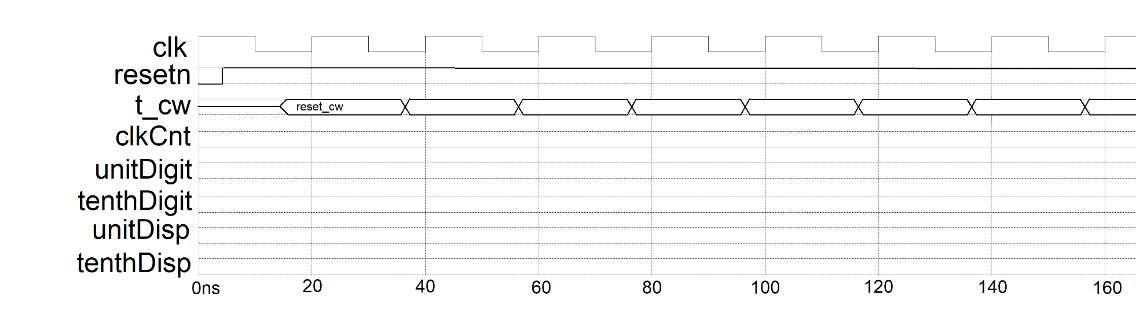

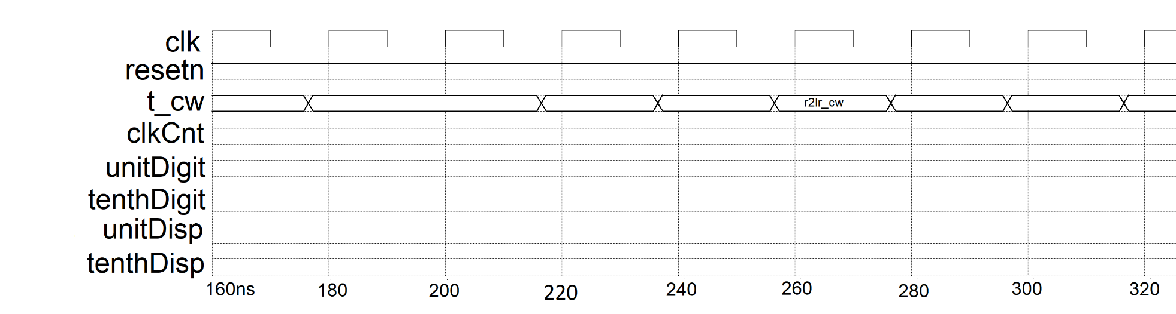

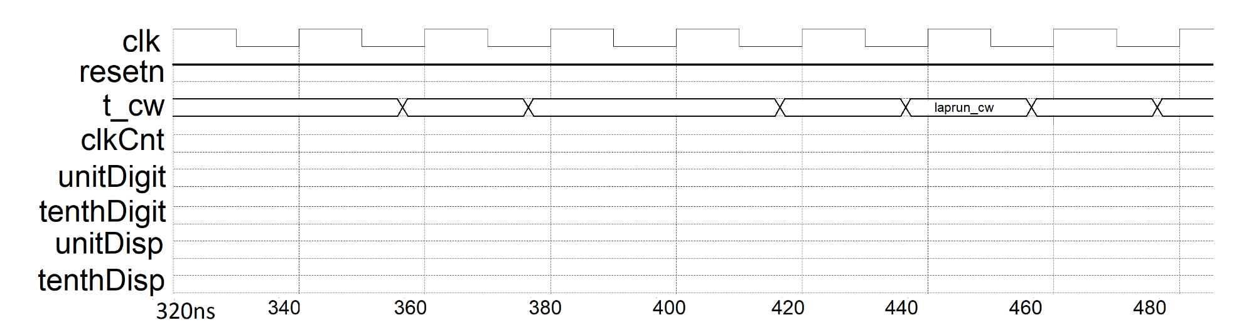

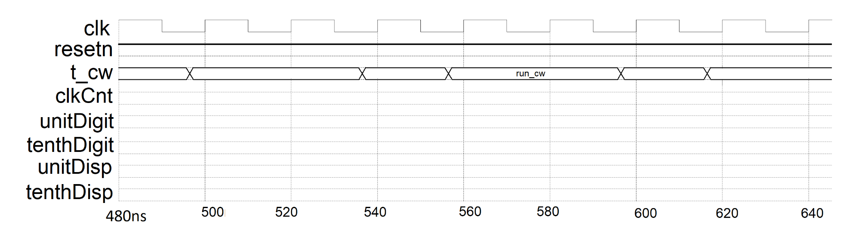

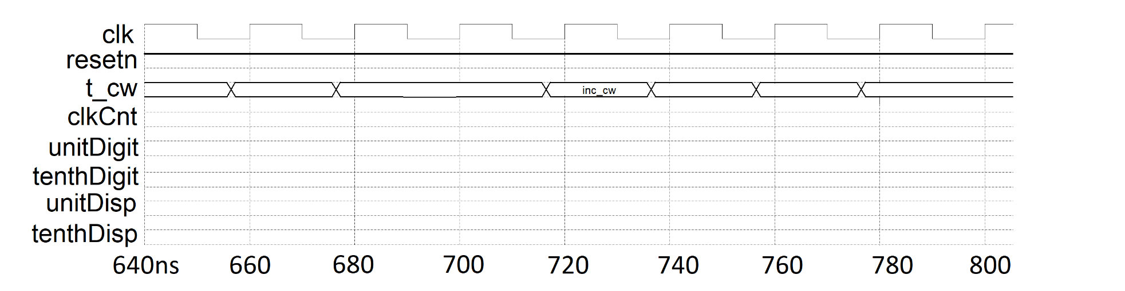

Run the testbench for the datapathLab09_tb module using the do file provided. Produce a timing diagram ordered from top to bottom as:

* + clk default green trace
  + resetn default green trace
  + cw hex yellow trace
  + tenth default gold trace
  + clkCnt hex red trace
  + tenthDigit hex green trace
  + tenthDisp hex green trace
  + unitDigit hex greenyellow trace
  + unitDisp hex greenyellow trace

In order to simplify the process of setting up the waveforms, you can script all the wave adds, assignment of radix and colors using the provided DO file as follows:

* Download “datapath_tbWaveSetup.do” into the: <projectDirectory>\<projectname>\simulation\modelsim
* Open datapath_tbWaveSetup.do file using Notepad. The syntax is pretty straight forward and corresponds to the text displayed in the ModelSim console window as you make modifications to the waveforms.
* You should use the do file immediately after you launch Model Sim by typing:
  + VSIM 3> do datapath_tbWaveSetup.do

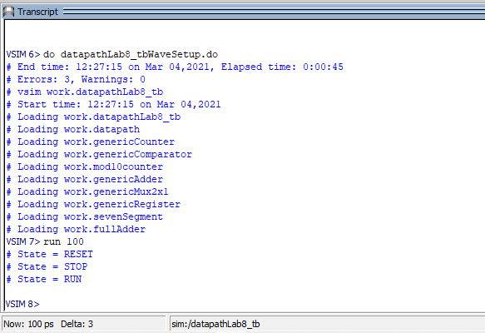

* You can type “run <time>” in this area (as shown) to simulate some amount of time. I found this VERY handy when debugging my Verilog code.
* Also note that the console has tab completion. This allows you to type the first few characters of a command/filename and press Tab to fill in the rest of the command/filename. If there is more than one choice, the command/filename will be completed up to the ambiguity.

You need to look at the values produced by the datapath and compare them against the values in Table 2. Look for discrepancies starting at time 0 and only advancing the simulation when everything is correct. You will have to transcend the design hierarchy to find the source of your errors. Most of my errors are due to incorrect wiring or modules – wrong names or wrong signal order.

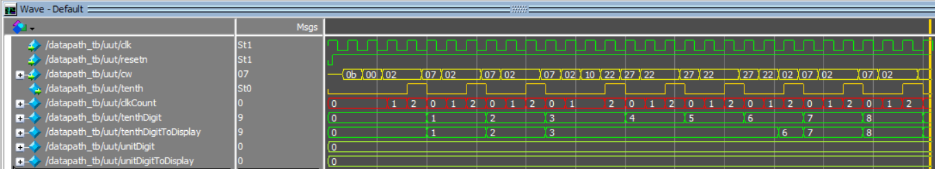

# Turn in:

You may work in teams of at most two. Make a record of your response to the items below and turn them in a single copy as your team’s solution on Canvas using the instructions posted there. Include the names of both team members at the top of your solutions. Use complete English sentences to introduce what each of the following listed items (below) is and how it was derived. In addition to this submission, you will be expected to demonstrate your circuit at the beginning of your lab section next week.

# Datapath

* Complete Table 1, and Table 2.
* Verilog code for the body of the datapath module (courier 8-point font single spaced), leave out header comments.
* Copy of your timing diagram. Fill horizontal space and use signal color and order given.
* Demonstrate that your datapath and do file work in ModelSim.